**Step 1: Create a New User Group**

1. **Log in to the** [**Azure Portal**](https://portal.azure.com/).
2. In the left-hand menu, search for and select **Azure Active Directory**.
3. In the **Microsoft Entra ID** pane, select **Groups** from the left-hand menu.
4. Click **+ New group** at the top.
5. Fill in the details for the group:
   * **Group type**: Select **Security**.
   * **Group name**: Enter a name for the group (**VM Operators Group**).
   * **Group description**: VM Operators Group they can read, start and stop.
6. Once you've entered the details, click **Create** to create the group.

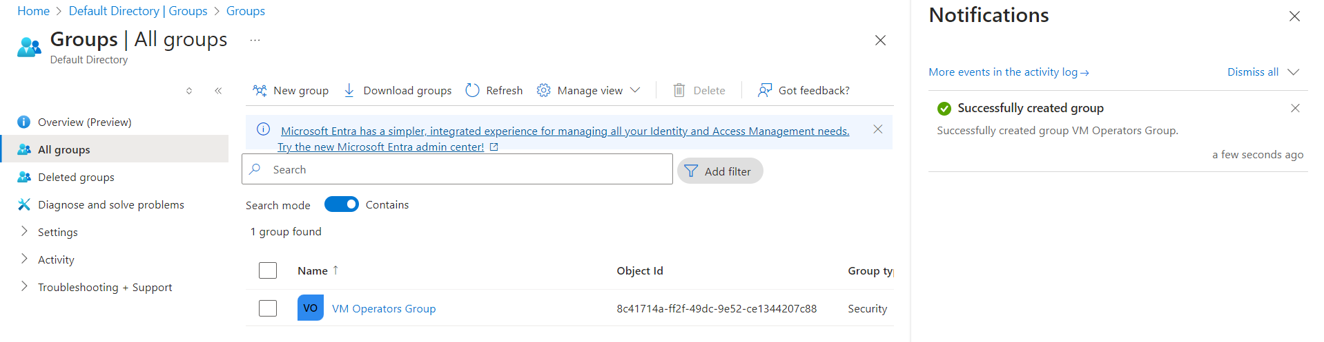

**Step 2: Attach the Custom Role to the Group**

1. Navigate to the **Access control (IAM)** section of the resource where the role is to be assigned (for example, a **Resource Group** or **Subscription**).
   * You can do this by going to the resource in question (e.g., Resource Groups, Subscriptions) in the **Azure Portal**.
2. In the **Access control (IAM)** pane, click on **+ Add**, and then select **Add role assignment**.
3. In the **Role** dropdown, search for the custom role you created earlier (**View Access**).
4. In the **Assign access to** dropdown, select **User, group, or service principal**.
5. In the **Select** field, search for the newly created group (**VM Operators Group**) and select it.
6. Click **Save** to assign the custom role to the group.

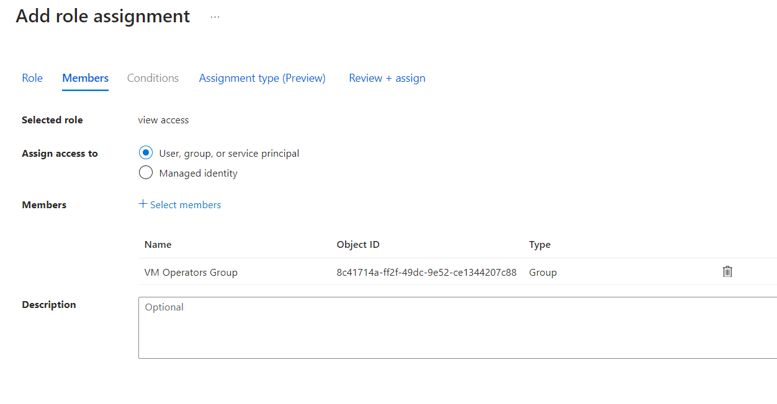

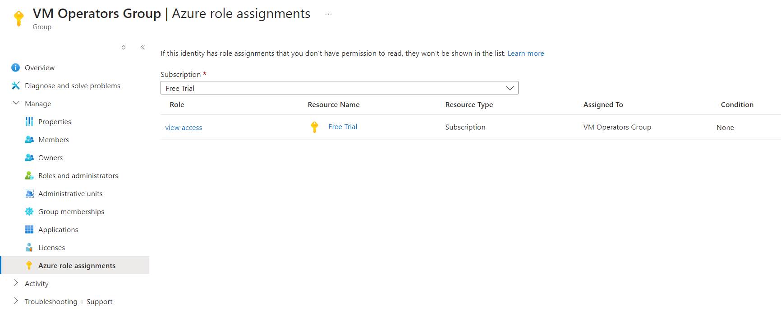

**Step 3: Add New Users to the Group**

1. Go back to **Azure Active Directory**.
2. Select **Groups** from the left-hand menu.
3. Search for and select the group you created (**VM Operators Group**).
4. In the group pane, click **Members** in the left-hand menu.
5. Click **+ Add members** at the top.
6. Search for and select the users you want to add to the group.
   * You can add the user(s) you created earlier, or any other users.
7. Once selected, click **Select** to add the users to the group.

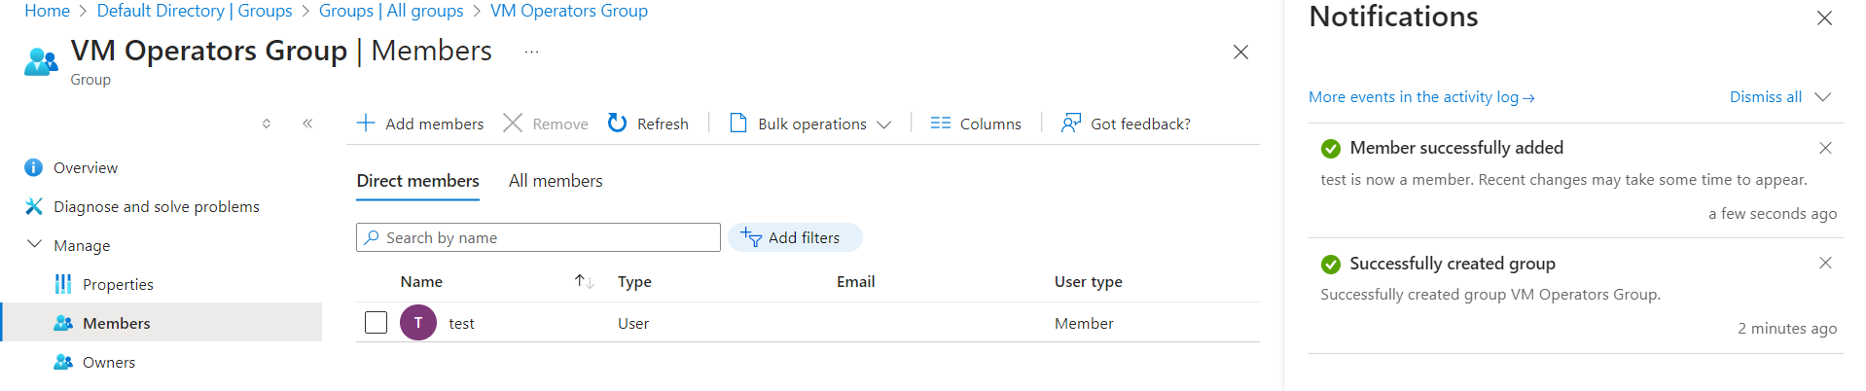

**Step 4: Verify the Permissions**

1. Log in as one of the newly added users.
2. Navigate to the **Virtual Machines** section in Azure and check if the user can:
   * View Virtual Machines.
   * Start Virtual Machines.
   * Stop Virtual Machines.
3. Ensure that the users do **not** have permissions to perform any other actions outside the defined role.

